|  |  |
| --- | --- |
| Bu resim için alternatif metin açıklaması yok  3D Modelling and Design at the FabLab - From Origami to Algorithmic Folding  Exhibition Idea Proposal 2 | Exhibition Idea Proposal 2  Ali Eren Kayhan  Bremen University  3D Modelling and Design at the FabLab  From Origami to Algorithmic Folding  03-IMVA-3DMFT (03-ME-899.08)  Dr. Bernhard Robben  Michael Lund  October 22,2022 |
|  |  |

Dr. Bernhard Robben University of Bremen

Michael Lund 3D Modelling with

FabLab Technologies

October 22, 2022

Winter Semester 2022/23

**Exhibition Idea**

**Proposal**

Content

Description of the main idea / motto 1

Concepts and theories (Include references) 1

Report how you realize a concept of folding with your design proposal 1

Documentation of the realization of your model including sketches, diagrams, pictures of your work, links to digital versions of the model 2

Bibliography 2

List of images 2

Progress report (Update every week) 5

# Description of the main idea / motto

I will build 3D model of Maiden's Tower (kız kulesi) in Blender. Then, I will use Pepakura Designer 5 to make my 3D model in 2D to use it in the laser cutter. Then, I use glue to connect each part. I will also add a QR code for my blog about my project so that people learn my project and Maiden’s Tower more.

# Concepts and theories (Include references)

I will use every skill that I learn in the course in this project. For example;

* Making 3D model in blender from images of target object
* Making 3D models in 2D models
* Using laser cutter

# Report how you realize a concept of folding with your design proposal

I will build 3D model of Maiden's Tower (kız kulesi) in Blender. Then, I will use Pepakura Designer 5 to make my 3D model in 2D to use it in the laser cutter. Then, I use glue to connect each part.

# Documentation of the realization of your model including sketches, diagrams, pictures of your work, links to digital versions of the model

Blog that I write = <https://alierenkayhanbouncet.blogspot.com/2023/01/how-to-build-madienstower.html>

Second link for my blog = <https://alierenkayhan.github.io/How-to-Build-Madien's-Tower/>

My GitHub Repository for my 3D model = <https://github.com/Alierenkayhan/Maidens-Tower_Blender_BremenUni_HW/tree/main>

<https://en.wikipedia.org/wiki/Maiden%27s_Tower>



# Bibliography

<https://en.wikipedia.org/wiki/Maiden%27s_Tower>

# List of images

Image of target object



My 3D model images

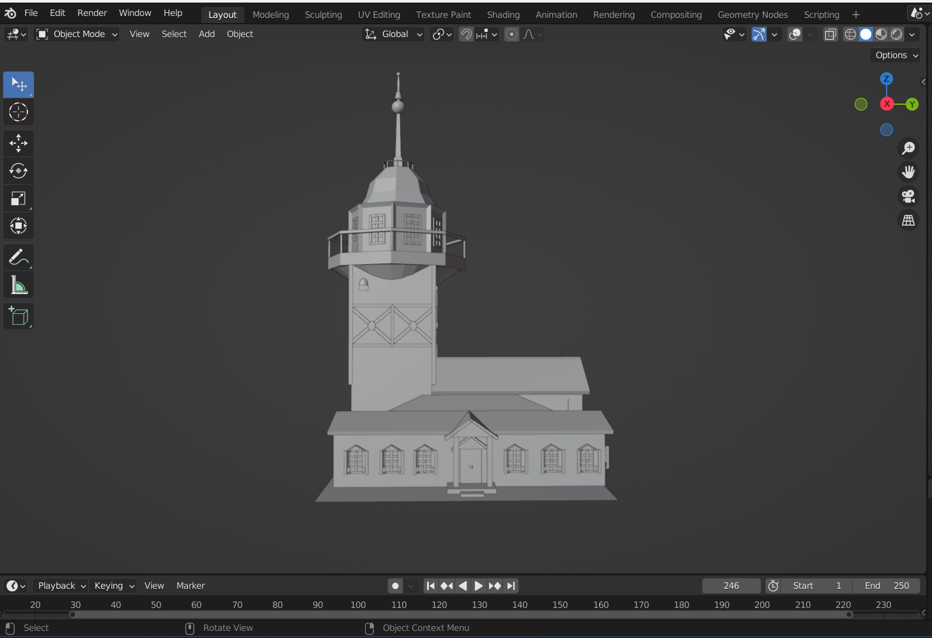

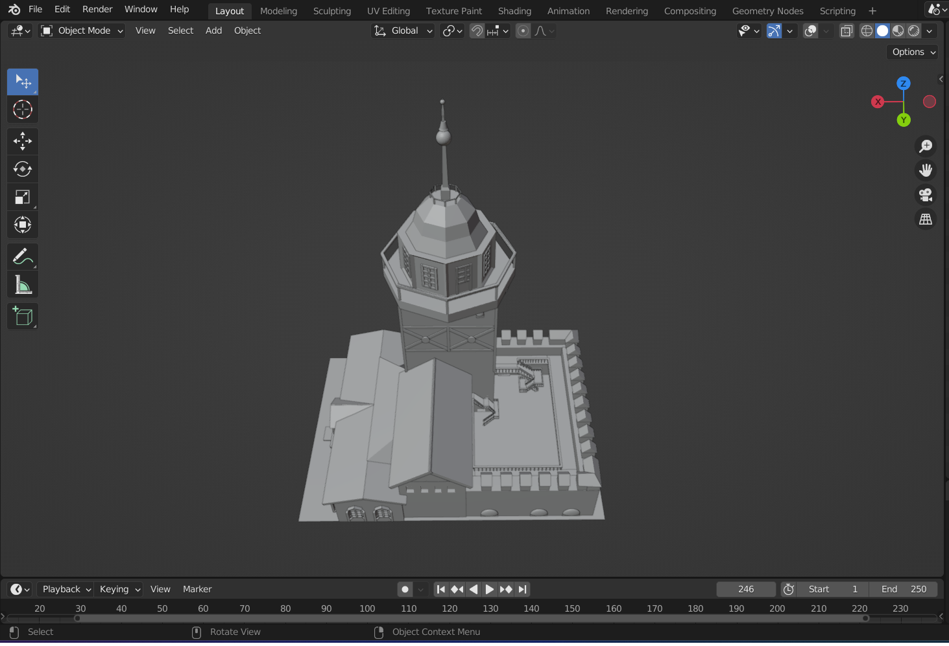

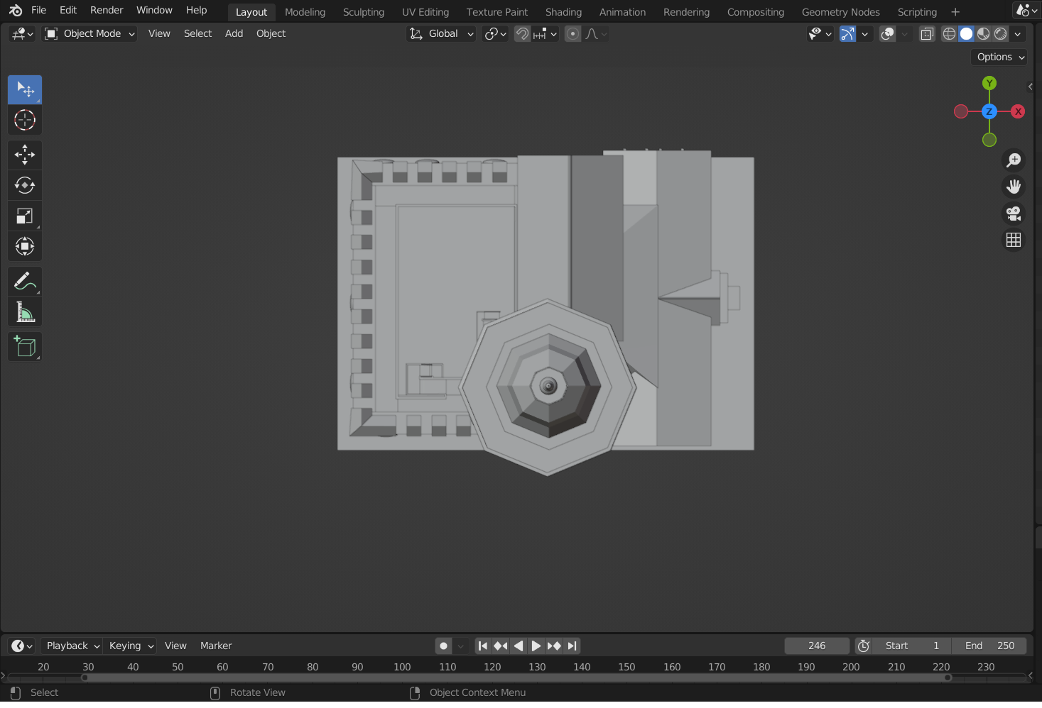

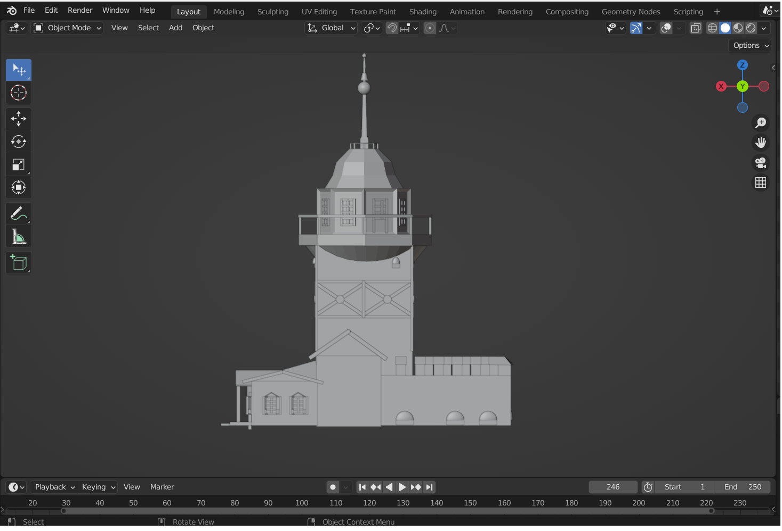

# Progress report (Update every week)

